Automated system for monitoring the verticality and dynamic parameters of masts / towers

Vladimir Ciclicci¹, Vasile Chiriac², Mihail Iacob³

¹ Dr. tech. science, Softcom S.A., Decebal 76 Bvd, Chișinău, MD-2038, Moldova Republic of. E-mail: vciclicci@gmail.com
² Assoc. professor, Technical University of Moldova, Stefan cel Mare Bvd 168, MD-2004, Chișinău, Moldova Republic of. E-mail: vasile.chiriac@clge.eu
³ General Director, Radocomunicatii I.S., Drumul Viilor Str, 28/2, MD-2021, Chișinău, Moldova Republic of. E-mail: mihail.iacob@radicom.md

Abstract. The construction of Automated System for verticality and dynamic parameters monitoring of towers/pylons is considered in that work. Modern technologies, such as MEMS sensors / inclinometers, IT, Cloud Computing, SCADA, Mobile Internet are used in the System.
Formulas for computing the tilt of towers/pylons on the base of sensors / inclinometers codes and methods of spherical geometry are developed.
Mathematical correlation between geodetically measurement data and sensors / inclinometers data are considered.
The determining of initial setup for the sensors / inclinometers are solved on the base of geodetically measurement data.
The graphical interfaces for monitoring process are developed.
Practical implementation of the automated system for towers/pylons verticality and dynamic parameters management as well as are developed. Practical implementation was carried out on the “Radiocomunicatii”, state enterprise of Moldova Republic of.
KEYWORDS: SCADA, tower, pylon, sensor, inclinometer, verticality, dynamic parameters.

- Introduction
New IT and electronic technologies such as MEMS [1], Mobile Internet, Cloud Computing, SCADA [2], etc. are being developed in recent years. Also new methods and automated geodetic monitoring systems are being developed, on their basis.
The current issues are the construction of automated monitoring systems for high-rise constructions (masts, towers) for monitoring verticality and dynamic parameters based on modern advanced technologies.
This article describes the experience of the development and implementation an automated system for monitoring the parameters of such high-altitude objects as masts and towers of radio-television installations in the Republic of Moldova.
The article also discusses the theoretical and practical issues of calculating technical parameters, such as oscillations and verticality according to the data of 2-axis MEMS sensors (inclinometers) of the system.
The paper describes the architecture of the monitoring system, the bases of engineering measurements and calculations, provides a practical example of calculations for the tele-radio masts/towers.

- System architecture
Figure 1 shows the general scheme of the System.
The mast at the left is shown. Sensors / inclinometers are fixed at the fastening levels of braces (supporting and regulating the inclination of the mast). The sensors through thunder-protection modules are connected to a common cable and transmit information (data) through an RS-485 interface. The lower end of the RS-485 cable is connected to the HOST-CONTROLLER, which manages and communicates with sensors and a 3G modem. 3G modem implements data exchange with WEB-PORTAL SERVER via the mobile Internet.
WEB-PORTAL SERVER stores the sensor data received via the Internet from a 3G modem. Server application software processes the sensor data array and implements the user interface for displaying information. The user gets access to the Server via the Internet to the workstation (Figure 1).

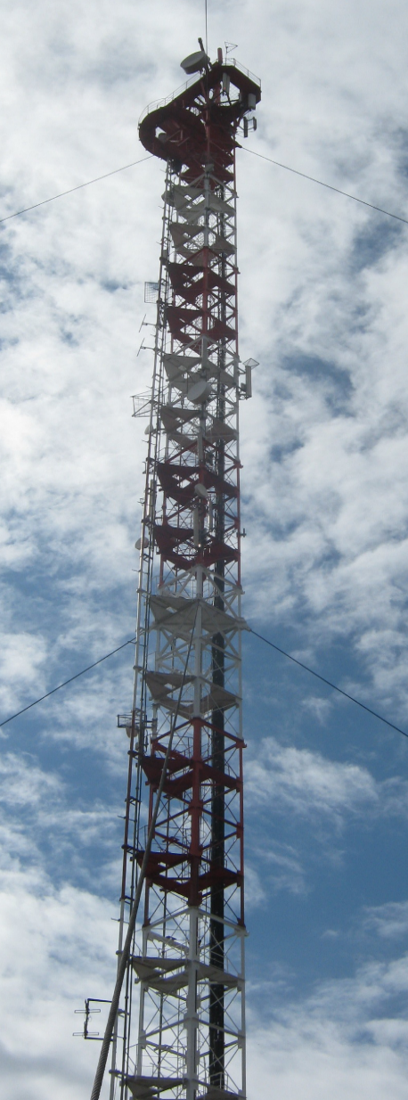
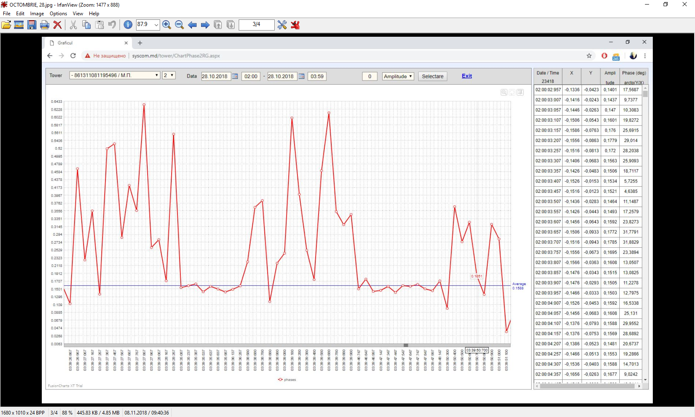

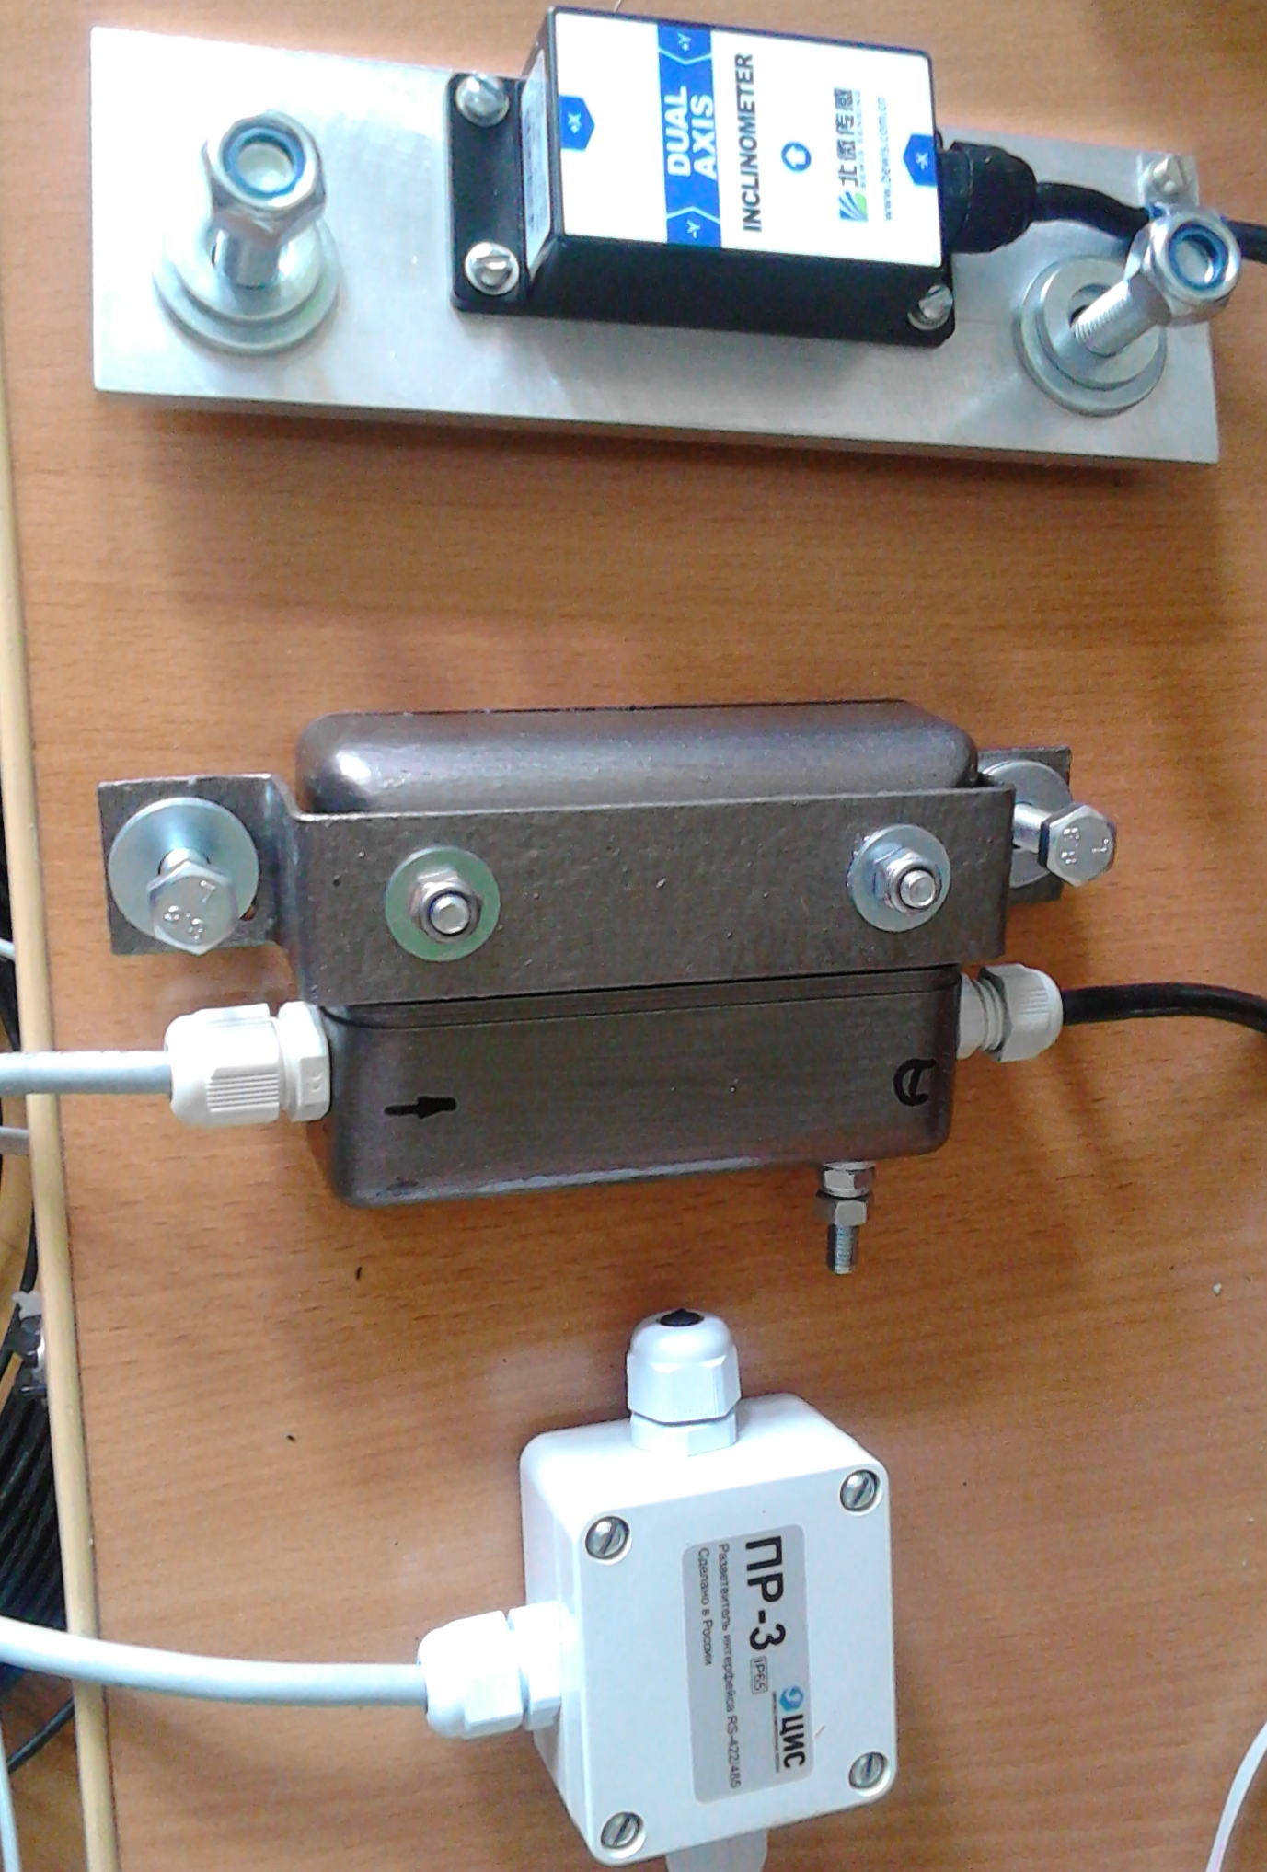
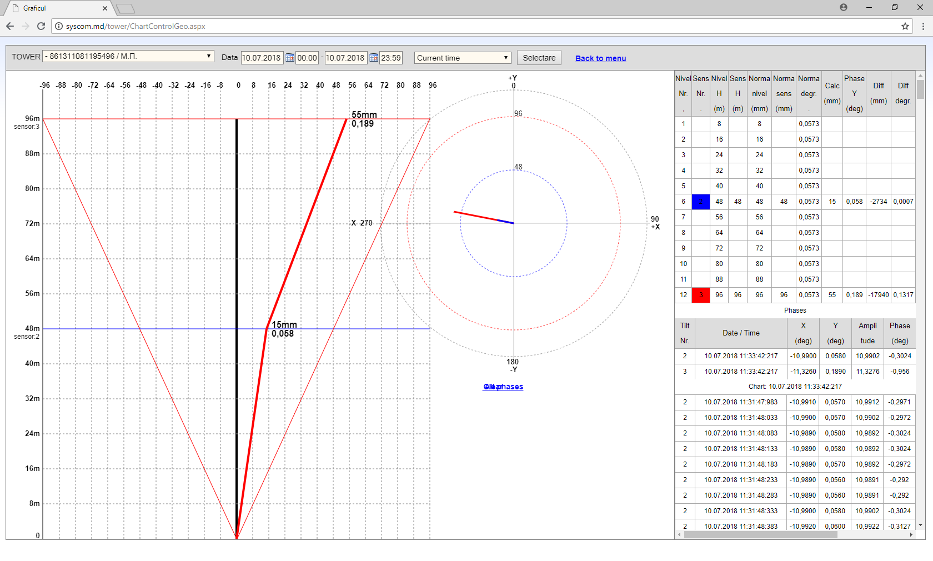
WORK STATION

INTERNET

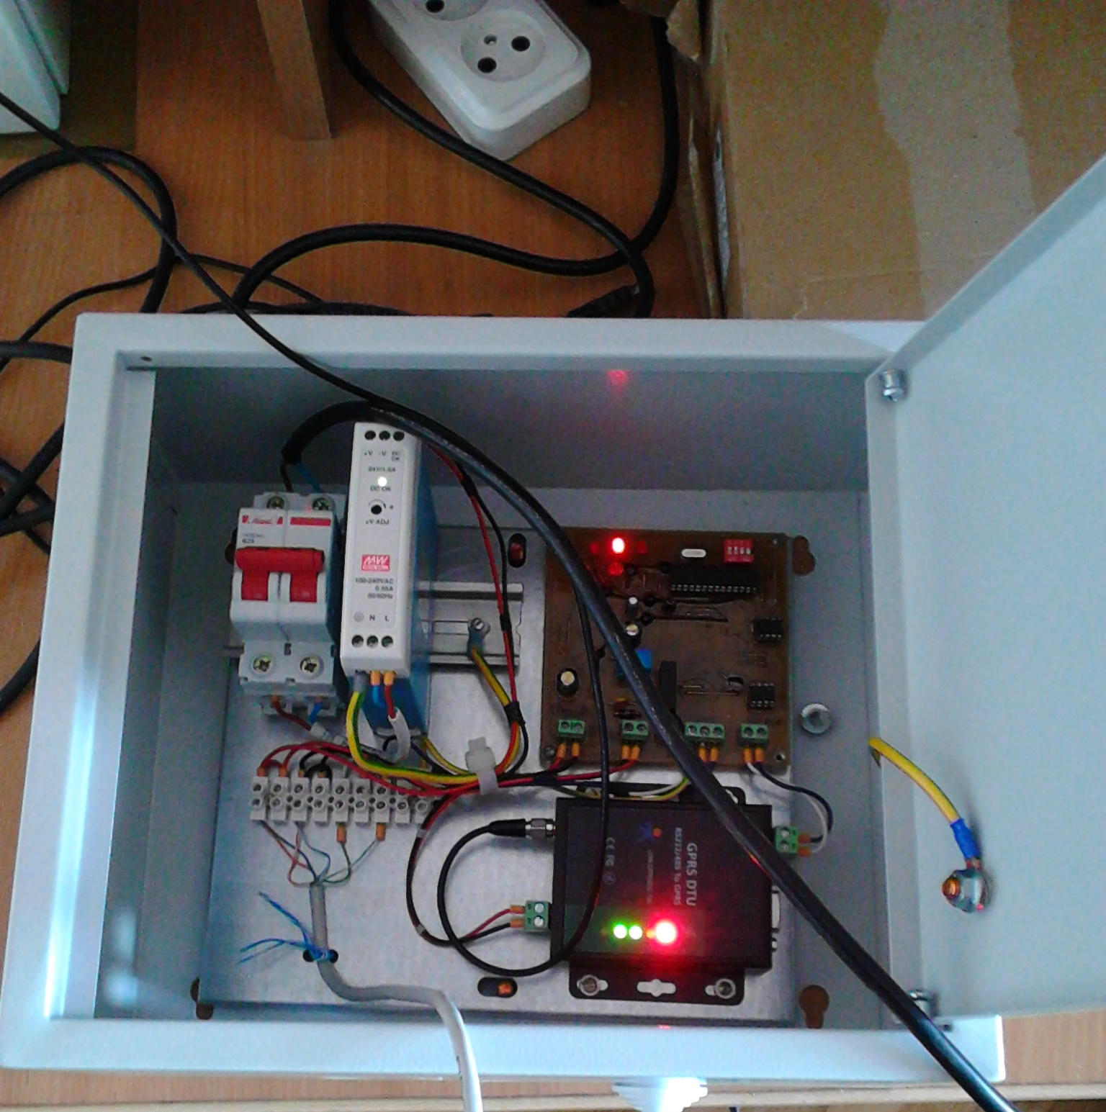 3G-MODEM
HOST CONTROLLER

WEB-PORTAL SERVER
3G 3G

Figure 1. System Architecture.
- System Functionality
The main user interface window is shown in Figure 2.

DATA DIRECTORIES TRAFFIC SUPERINTENDENT ADMINISTRATION
Data directory editing Alarms Configurations
Track Viewer

STATISTICS USER INTERFACE LANGUAGES
Chart Romana
Verticality English
Русский

Figure 2. The main user interface.
The main functions of the System are STATISTICS-Chart and STATISTICS-Verticality.
The STATISTICS-Chart shows mast oscillations in real time at intervals of 50 milliseconds (Figure 3).
Figure 3 shows a graph of oscillations of mast during the earthquake on October 28, 2018 (Hîncesti, Moldova, time 3 hours 39 minutes 27 seconds, the epicenter of Vrancea, Romania).

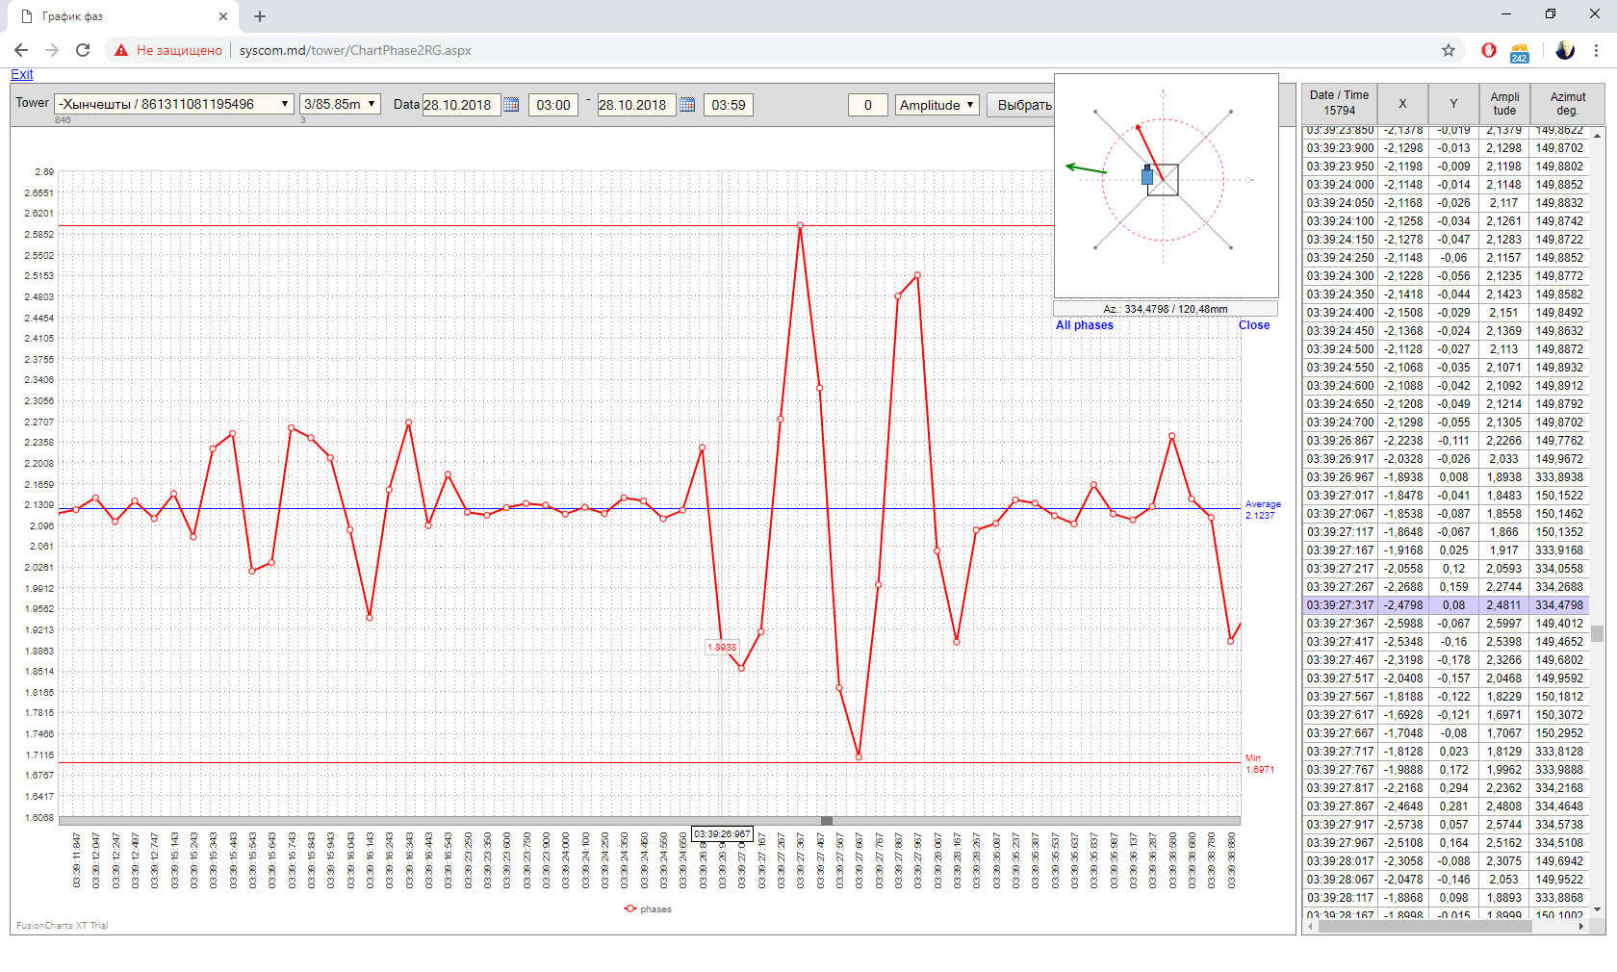

Figure 3. Graph of oscillations of mast during the earthquake.

STATISTICS - Verticality shows a constant deviation of the mast / tower from the vertical position (Figure 4).
The levels of the sensors (red horizontal line and blue horizontal line) is shown to the left. Dotted lines limit the permissible deflection angle of the mast, and solid inclined - the inclination of the mast at two levels of sensors, which coincide with the levels of fastening of control stretch marks. From Figure 4 it can be seen that the upper part of the mast is outside the tolerance limits and needs to be straightened.
The right shows a top view of the mast and shows the amplitude of the slope vectors and the direction (azimuth) of the mast slope vector. The blue circle and the red circle show the permissible deviation limits for the lower and upper sensors, respectively. The table shows the calculated quantitative parameters.
Figure 5, Figure 6 shows an alarm in case of exceeding the permissible limits of deviation or fluctuation of the mast / tower (TRAFFIC SUPERINTENDENT-Alarms, Figure 2).

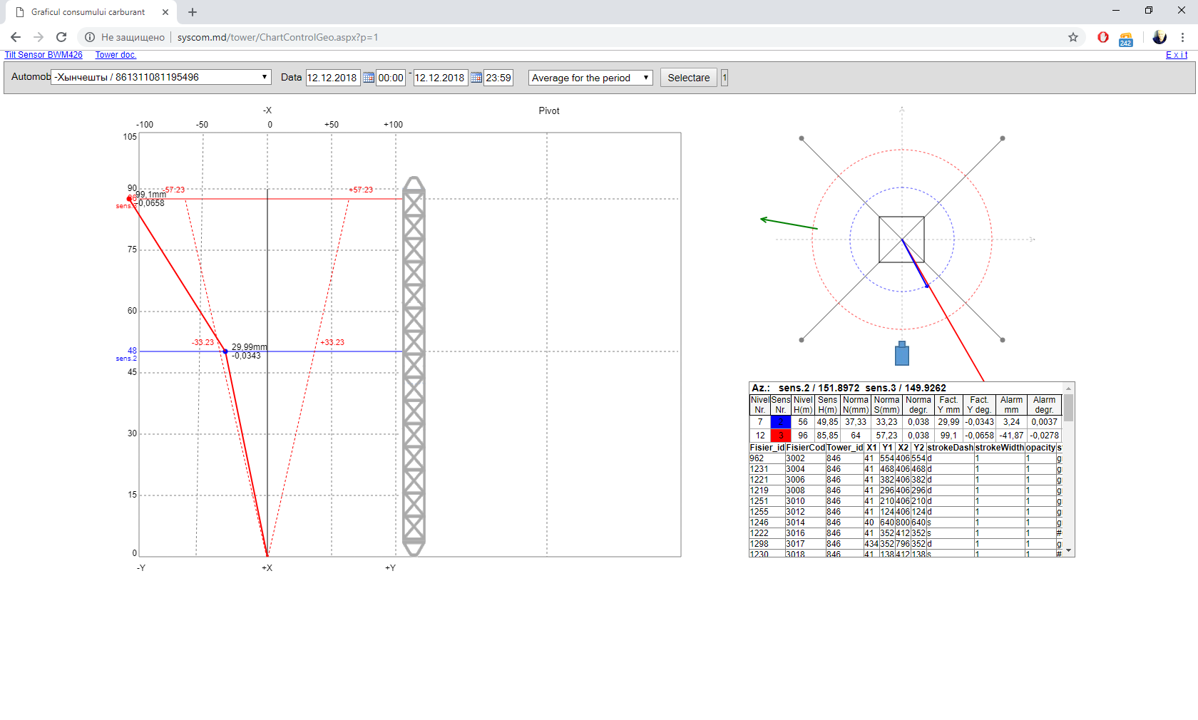
Figure 4. Verticality- constant deviation of the mast

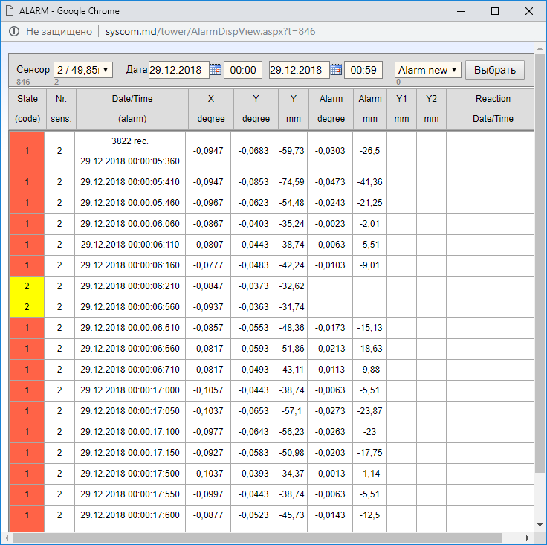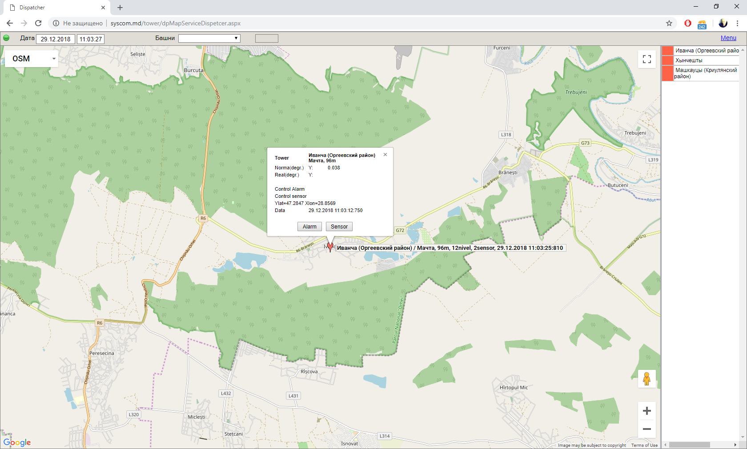
Figure 5. Alarm chart. Figure 6. Alarm map.

- Engineering measurements and calculations
There are many technologies and methods for measuring various parameters in the manufacture, construction and operation of high-rise structures, in particular masts and towers [3,4,5,6].
The main parameters to be measured during the operation of metal masts and towers are dynamic parameters and stability parameters.

  - Model
As an example, consider the measurement of the slope (verticality) of a mast with a 2-axis sensor-inclinometer (Figure 7).

Axis +z

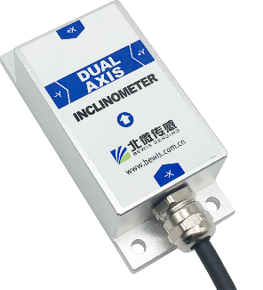
Angle +X
Axis + y¹
Axis +x¹
Angle +Y

Figure 7. Biaxial sensor.

The arrows show the angles of rotation of the sensor (X, Y). The axes (x, y) represent a system of rectangular coordinates matched in directions with the angles of rotation and rigidly attached together with the sensor to the mast (Figure 8). Define the x, y, z coordinate system (Figure 8, Fig.9) as the base (normal) coordinate system of the mast-sensor, with x, y, z forming the right triple [7], [8], were the x¹ axis is parallel to x and the y¹ axis is parallel to y but opposite in direction. The z axis is one.

z
B x¹
x* B*
F y¹
y*

Ө
y
O x

Figure 8. Rotation of sensor and mast

If you compare the coordinates of Figure 7 with the coordinates of Figure 9, then you can see that the coordinates of the sensor x¹, y¹, z forms the right three, if you change the sign of the y axis to inverse
(y¹ = -y). This must be taken into account in further calculations.
Figure 8 shows the mast model when tilted in 2 positions: 1) upright-ОB and inclined- ОB*. The sensor is located perpendicular to the vertical axis of the mast. The angle F is the vector of the angle of the sensor, and the angle Ө is the vector of the angle of the mast. From Figure 8 it can be seen that the angle F is equal to the angle Ө, as are the angles with mutually perpendicular sides (OB is perpendicular to x*, and OB * is perpendicular to y *), i.e. the mast tilt vector is equal to the tilt vector of the sensor in the agreed coordinate systems of the sensor and the mast.

z
B
C x¹
φ
A 90° a y¹ R
V Vz
b Ө
C y
Vx O x
φ
С´ Vy

Figure 9. General case of mast tilt with sensor

The top of the mast B with a fixed sensor moves along a sphere with a radius equal to the height of the mast OB, when tilting the mast with a fixed base O. This position is also valid for any intermediate point of sensor attachment on the OB axis.
Consider the general case of tilting the mast- sensor (Figure 9). Sensor movement from point B to point C can be represented as a vector sum of 2 movements: from point B to point A plus movement from point A to point C along a sphere with radius OA, where the spherical angle BAC is a rectangular [8].
Here A, B, C are spherical angles, and the letters a, b, c are opposite corresponding arcs [8].
According to the formulas of spherical trigonometry [8]:

a = arccos (cos b × cos c) (5)
B = arctg (tg b / sin c). (6)

a- amplitude of the deflection angle of the ОB axis;
B-amplitude of the angle of deviation direction relative to the x, z.

In practice, at small deflection angles, as well as with a large radius R = OB (compared to an angle in radians), the triangle ABC can be considered planar and rectangular in the normal coordinate system x, y, z (or x¹, y¹, z), where angle A is rectangular, and tg b = b, sin c = c. Then formulas (5), (6) take the form:

a = √ (c² + b²) (7)
B = arctg (b / c) (8)

  - Dynamics (STATISTICS- Chart)

Figure 3 shows the dynamics of oscillations during an earthquake. The top right shows the direction of oscillation of the mast at time 03 h. 39 min. 27sec. 300 msec.
The average line (Average on Figure 3) is calculated by the formula:
$Aav=\frac{1}{n}\sum_{k=0}^{n}{Ak}$ (9)
Where $Aav$ is the average value of a sample of n values,
Ak is the amplitude of the k sample.
Considering that the mast is in a state of oscillation relatively to some inclined axis, then we will consider the average value of Aav as a vector of constant inclination of the mast relative to the vertical.
  - Verticality (STATISTICS- Verticality)
Verticality is calculated for each sensor located on the mast / tower. Figure 4 shows an example of a mast with 2 installed sensors at the attachment points of the stretch marks. Vertical vector is calculated:
a) For a constant slope according to the formula (9) -Fig.4, Average for the period,
b) For maximum deflection during vibrations - Maximum for the period,
c) For a specific time, for example, during an earthquake - Selected time.

  - Correction (ADMINISTRATION – Configurations)
There is almost always a sensor's own inclination relative to the mast / tower when installing the sensor on the mast / tower, therefore the sensor readings contain information about the total inclination of the sensor relative to the mast / tower and the mast/tower relative to the vertical.
To determine the verticality of the mast / tower itself, it is necessary to subtract the slope of the sensor relative to the mast / tower from the total sensor readings and determine the permanent correction to the total sensor data. This can be done in 2 main ways:
a) Straighten the mast / tower vertically and take a sensor reading. These readings will correspond to the tilt of the sensor relative to the mast/tower and will continue to serve as constant amendments. However, in practice, especially when installing the system, this method is inconvenient, because aligning the mast/tower vertically is a complicated and expensive procedure.
b) Measure the current position (inclination) of the mast / tower by the geodesic method and simultaneously take readings of the installed sensor. Subtract from the sensor readings measured by the geodesic method, the given readings of the verticality of the mast / tower and take the result as a permanent amendment. This method requires only a geodetic measurement of the mast / tower once, and after calculating the correction, it allows to use the sensor readings in real time to determine the true inclination of the mast / tower and align the latter using these readings.
Figure10 shows an example of a geodetic measurement with an image of a vertical pattern for a mast.
As can be seen from Figure 10, geodetic measurements of verticality were made from two mutually perpendicular directions (axes): St1 and St 2. We define the coordinate system St1, St2, z as Geodetic (x *, y *, Figure 11). Figure10 shows the permissible angle of inclination from verticality and the results of measurements at two levels of stretch marks (40.9 m and 86.9 m) - the permissible and real linear deviation (mm) at both levels and from both directions St1 and St2. Sensors are installed at stretch marks (40.9 m and 86.9 m), respectively. The sensors are located in the identical directions. Figure 11 shows a top view of the mast, which is a square with a sensor located in the center.
We define the normal coordinate system: the coordinate axes of the sensor and the mast are x, y; sensor angles - X, Y, coordinate axes of geodetic measurements - x *, y * (Figure 11). The vector O-O¹ or simply O¹ is the verticality vector of the sensor, and O * is the verticality vector of the mast, obtained as a result of independent geodetic measurements. The vector ΔO is the verticality vector of the sensor relative to the mast, which will be considered defined at the time of installation of the sensor and unchanged in the future.
From Figure 11 it is obvious: O¹ = O * + ΔO, or:

ΔO = O¹- O * (10)

To determine the vector of the constant correction of the sensor readings, it is necessary to subtract the vector of geodetic measurements of the mast tilt at the same time from the vector of sensor readings at a specific time.

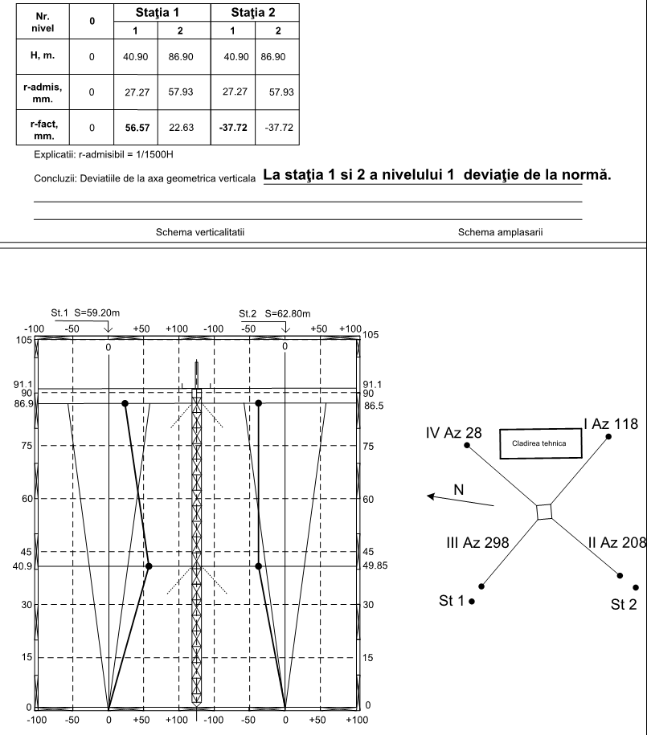
Figure 10. Geodetic measurement

Since in our example the sensor is angular, 2-axis, then the correction vector must be determined in 2 axis axial coordinates (X, Y). From Figure 11 it can be seen that the geodesic coordinate system (x *, y *, z) does not coincide with the basic spherical coordinate system (x, y, z), but is rotated in the horizontal plane by an angle G. For compatibility, we will make a rotation geodetic coordinate system at an angle G and determine the geodetic coordinates in the basic spherical coordinate system [9]:

x * ₒ = x * cosG + y * sinG, (11)
y * ₒ = - x * sinG + y * cosG (12)

where x * ₒ, y * ₒ are geodetic coordinates in the basic x, y coordinate system.
Now it is necessary to convert the linear coordinates x * ₒ, y * ₒ into angular X *, Y *.
According to the formulas for the transformation of coordinates from the Cartesian system to the spherical (Fig.9), [10] we have:

V=$√(x*˳²$+y*ₒ²+z*ₒ²) (13)

Ө=arccos($\frac{z*ₒ}{√(x*˳²+y*ₒ²+z*ₒ²)}$)=arctg[$\frac{√(x*˳^{2}+y*ₒ^{2})}{z*ₒ}$] (14)

φ = arctg$\frac{y*ₒ}{x*ₒ}$ (15)

z*ₒ = H and represents the height of the geodetic measurements (Figure 10).
From formulas (13,14,15) we find the corrections of geodetic measurements in the angle parameters of the sensor X, Y.
Using the orthogonality property, we find alternately corrections Xc, Yc.

+y=-y¹
+y*
+X

G
O¹
Ө*
O*

+x
ΔO
Q
O
+Y

+x*

St 1 St 2

Figure 11. Top view of the mast

In the formulas (13,14,15) for finding Xc take y*ₒ = 0:

V=$√(x*˳²$+H²) (16)

Өx=arccos($\frac{H}{√(x*˳²+H²)}$)=arctg[$\frac{x*ₒ}{H}$] (17)

φ = arctg$\frac{y*ₒ}{x*ₒ}$=0 (18)

It follows:

Өx= arctg$\frac{x*ₒ}{H}$, (19)

Өy= arctg$\frac{y*ₒ}{H}$ (20)

Taking into account the angle of rotation of the coordinate systems by the angle G (11,12), substituting in (19, 20), we obtain the expressions for the angular corrections:
X*c= Өx= arctg$\frac{x*cosG+y*sinG}{H}$

Y*c= Өy= arctg$\frac{-x*sinG+y*cosG}{H}$

We take into account the transformation y¹=-y for the sensor (Figure 7), then we finally get the expressions for corrections of the sensors:

X¹*c= arctg$\frac{x*cosG+y*sinG}{H}$ (21)

Y¹*c= arctg$\frac{x*sinG-y*cosG}{H}$ (22)

An example of sensor readings at the time of surveying Time measurements (Tab.1):

Tab.1. Sensor readings
Sensor  Nr. | Hs  м | Date/Time | X  deg | Y  deg | Amplitude  deg | Azimuth  deg
2 | 49,85 | 19.07.2018 02:19:32:410 | 1,1890 | 0,3540 | 1,2406 | 16,5798
3 | 86,85 | 19.07.2018 02:17:47:293 | -1,1390 | 0,2220 | 1,1604 | -11,0291

For our example (Fig.8,9): G = 45 °, therefore, formulas (21), (22):

X¹*c= arctg 0,707 $\frac{x*+y*}{H}$ ,

Y¹*c= arctg$0,707\frac{x*-y*}{H}$.

We get for sensor No.3 substituting the data from Fig.10 and Tab.1:

X¹*c(3) = arctg$0,707\frac{22,63-37,72}{86850}$=-0,007°

Y¹*c(3)= arctg$0,707\frac{22,63+37,72}{86850}$= 0,028°

Considering the sensor readings at the time of the geodetic measurements (Tab.1), we get the final corrections:
Δ X¹*c(3)= -1,1390°-(-0,007°)=-1,132°
Δ Y¹*c(3)= 0,2220- 0,028= 0,194°.

- Conclusions

Modern technological advances in the field of electronics and systems engineering, such as MEMS, Mobile Internet, Cloud Computing, SCADA etc., allow developing and implementing effective systems for monitoring such geodetic parameters of masts / towers as verticality and oscillations.
For effective commissioning of such systems, it is necessary to use traditional geodetic techniques for the initial alignment of high-precision sensors when installed on a mast / tower.
The developed monitoring system has shown its effectiveness in operation.
The developed mathematical apparatus on the base of spherical geometry and software can be used to build automated systems for monitoring geodetic parameters such as verticality and oscillations of high-rise structures.

References
[1] https://en.wikipedia.org/wiki/Microelectromechanical_systems
[2] https://www.yokogawa.com/us/library/resources/application-notes/scada-cloud-computing/
[3] Шеховцев Г.А. Современные геодезические методы определения деформаций инженерных сооружений: монография; Нижегород. Гос. Архит.-строит. Университет- Н. Новгород: ННГАСУ, 2009. -156с.
[4] TIA STANDARD. Structural Standard for Antenna Supporting Structures and Antennas, 2005.
[5] Шакирзянов Р.А., Шакирзянов Ф.Р. Ш17 Динамика и устойчивость сооружений: Учебное пособие. − 2-е перераб. изд. / Р.А. Шакирзянов, Ф.Р. Шакирзянов. − Казань: Изд-во Казанск. гос. архитект.-строит. ун-та, 2015. − 120 с.
[6] https://csengineermag.com/article/surveying-a-towers-movements/
[7] M. Iacob, V. Chiriac, V. Ciclicci. Study of the Inclinometer Calibration Method using Geodetic Measurements. http://revcad.uab.ro/upload/44_710_Iacob.pdf
[8] P. Kranz. SPHÄRISHE TRIGONOMETRIE. Сферическая тригонометрия. Пер. с нем./Под ред. Я.Н. Шпильрейна. М:ЛКИ, 2007.-96с.
[9] http://angem.ru/analiticheskaya_geometriya/?lesson=4&id=13
[10] http://www.programmersforum.ru/showthread.php?t=97522

